**SCHEDULE B: Position Description**

**Sustainability Project Officer - Cadetship Program**

|  |  |
| --- | --- |
| **Location** | **NSW Hunter Region (Thornton)** |
| **Date position description approved** | **24 February 2025** |

The Organisation

The Hunter Joint Organisation (Hunter JO) is a collaborative organisation of the ten Councils of the Hunter region of New South Wales that facilitates the delivery of strategic advocacy and program outcomes for the entire region. Our principal statutory functions include:

* Regional strategic planning and priority setting
* Intergovernmental collaboration
* Shared regional leadership and advocacy.

Being a hub for local government collaboration, the Hunter JO provides a united and local voice for communities throughout the Hunter region. The Hunter JO is a growing organisation, with an exciting and diverse range of advocacy initiatives and programs that are delivering real outcomes for our region.

The Board of the Hunter JO comprises the Mayors of the ten Councils of the Hunter Region.

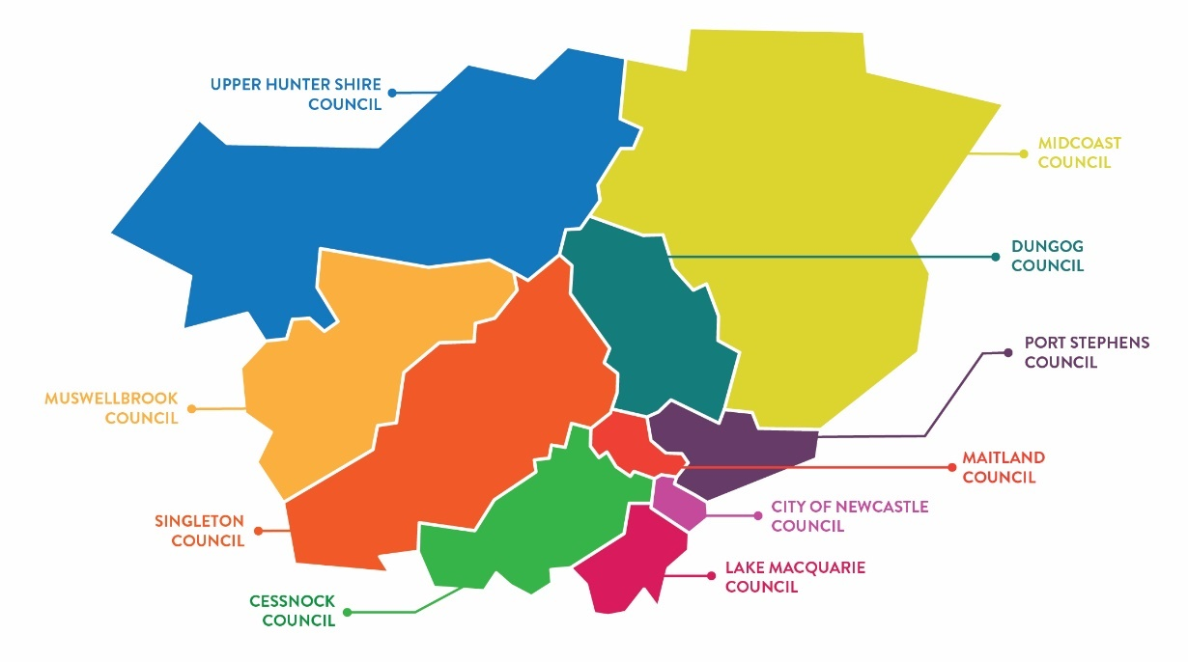

Our values

Collaboration is key to our success. It allows us to create innovative solutions, efficient processes, improved culture, and is a defining strength for our organisation. Our focus on place-based leadership and collaborating with Councils, government, industry and community partners on the region’s key issues and priorities makes the Hunter JO a dynamic, innovative and exciting organisation in which to work.

Purpose of the Role

The role is responsible for delivering collaborative regional projects in the Hunter JO’s priority focus areas: Connectivity; Resilience; Jobs and a Growing Economy; and Liveability.

The role will work closely with other JO staff and a wide range of external stakeholders including member Councils, State Government agencies, research institutions, business and community groups.

Key functions of the role include stakeholder engagement and management; research and analysis; and project delivery, that contribute directly to implementation of regional projects and initiatives being delivered by the Hunter JO.

Key Responsibilities of the Role

* Undertake research and synthesis of data and information to help design or deliver regional projects.
* Assist in the coordination and facilitation of multi stakeholder project committees and working groups to build collaboration in the delivery of regional projects.
* Assist the project managers in the delivery of our projects, including engaging and managing consultants, contractors, project partners and stakeholders to ensure projects are delivered within established parameters, timeframes and budgets
* Contribute to organisational project management and reporting systems to monitor and ensure delivery of projects within available finances and timeframes, and to pre-emptively identify and manage emerging risks.
* Support the delivery of workshops and capacity building events with member councils and key stakeholders to build awareness, capacity and commitment to participate in the delivery of regional projects.
* Assist in the preparation of project proposals, business cases and grant applications to continue and expand the number of projects being delivered by the Hunter JO.
* Comply with cadet program and training plan.
* Any other accountabilities or duties as directed by your supervisor which are within the cadet’s skill, competence and training.

Key challenges

* Working in a complex and time constrained environment.
* Participating in multiple projects with conflicting priorities.
* Understanding and responding to the diverse priorities the member councils and various project stakeholders.
* Understanding and identifying emerging risks.

Key relationships

| Who | Why |
| --- | --- |
| **Internal** |  |
| Hunter JO Board | * Support project managers in providing advice and reports on the status of project delivery. |
| Hunter General Managers Advisory Committee | * Support project managers in providing advice and reports on the status of project delivery. |
| Manager | * Liaise and report regularly on the focus, planning and delivery of day-to-day work program. * Collaborate on the development of project plans and their delivery * Monitor and report on the progress and effectiveness of project delivery. * Identify emerging issues/risks and their implications |
| Hunter JO Policy and Programs Team | * Communicate regularly on the focus, planning and outputs of project initiatives. * Collaborate on the design and development of project plans and work programs. |
| **External** |  |
| Council staff (Hunter JO Member Councils) | * Support engagement and collaboration to deliver regional project initiatives. |
| Other Joint Organisations, peak advocacy bodies, and regional advocacy groups | * Support engagement and collaboration to deliver regional project initiatives. |

Reporting

|  |  |
| --- | --- |
| **Reports to** | Director of Programs |

Essential Requirements

1. Undertaking tertiary education in environmental management, science, health, planning, or other relevant discipline.
2. Ability to work in a team environment and work independently, and to exercise initiative and problem-solving skills, including the prioritisation and management of own work tasks.
3. Good interpersonal skills and emotional intelligence, including the ability to confidently liaise with a wide variety of people.
4. Good organisational skills.
5. Ability to undertake research, analyse outcomes, and communicate findings to various technical and non-technical audiences.
6. Competence with various software packages, for example but not limited to Outlook, Word, PowerPoint and Excel.
7. Class C NSW Drivers licence

Desirable Requirements

1. Previous work experience relevant to the role